Edward Auttonberry

**Lab 4: Newton’s Second Law**

6/14/2018

PHYS 261 – 005

With:

Zac Davis

Tyler Perry

and

Kierra Coleman

**Objective**

The objective of this lab was to study and understand the relationship between the net force on an object and that object’s acceleration. By the, the goal is to be able to determine the theoretical acceleration of a cart being pulled down a track by a hanging mass over a pulley.

**Theory**

The theory being tested is Newton’s Second Law of Motion. The principle states that “the force (*F*) acting on a body is equal to the acceleration (*a*) of that body times its mass (*m*), assuming a constant mass.” Conversely, the acceleration would be equal to the net force acting on an object divided by the constant mass thereof. This can be expressed mathematically as:

$a=\frac{F_{net}}{M}$ Eq. 4-1

The net force must be knowing to find the acceleration on a mass. In an approach where a hanging mass is connected to the mass in focus and being hung over a frictionless pulley, the gravitational force on the hanging mass will be applied directly to the mass in focus in the direction of the pulley. Therefore, we can determine the net force on the mass as follows, with a hanging mass of weight *m*:

$a=\frac{mg}{\left(M+m\right)}$ Eq. 4-2

**Procedure**

Both procedures of this lab involved taking readings from a force sensor and an accelerometer and analyzing the results of the two to verify against the theory defined above. For both procedures, it was important that one member was constantly holding the cables linking the devices on the cart in such a way as to prevent drag on it.

**Procedure A**, after setup, involved pulling and pushing the cart back and forth by the hook on the force sensor while the LabPro took readings of the current acceleration and force. The cart was weighed with the devices on. The analysis was performed on this data.

**Procedure B** involved linking a hanging mass to the hook of the force sensor and allowing the mass to pull the cart forward over 6 trials, each with an increased hanging mass. The acceleration of the trials was plotted against the respective forces to get an experimental estimate of the cart’s mass.

**Data**

Below is the LoggerPro plot of the Force vs. the Acceleration from Procedure A.

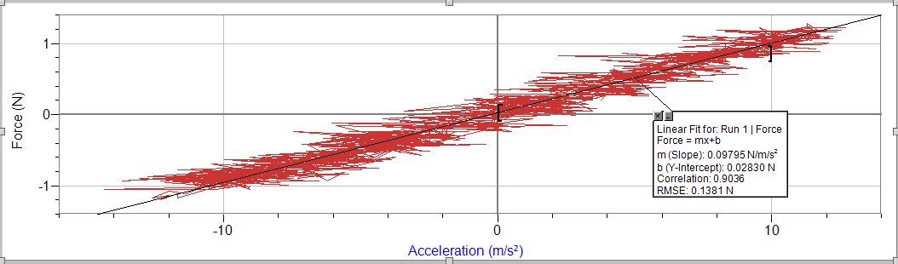

**Figure 4-1.** The plot of the force on the cart vs. the acceleration of the cart. The mass of the cart would be the slope of the trendline produced on this graph, which is shown to be 0.09795 kg.

Below is the table containing the results of the trials from Procedure B.

|  |  |  |  |  |
| --- | --- | --- | --- | --- |
| # | m (g) | acceleration (m/s2) | force (N) | M (kg) |
| 1 | 20 | 1.355 | 0.1339 | 0.098819188 |
| 2 | 50 | 3.508 | 0.3052 | 0.08700114 |
| 3 | 70 | 5.038 | 0.4134 | 0.082056372 |
| 4 | 90 | 6.129 | 0.5155 | 0.084108337 |
| 5 | 110 | 7.171 | 0.6107 | 0.08516246 |
| 6 | 130 | 8.72 | 0.7021 | 0.080516055 |

**Table 4-1.** The data from each of trials in Procedure B. For each trial, the table contains the weight of the hanging mass *m*, the average acceleration, the average force, and the derived weight of the cart *M* in kilograms.

**Analysis**

**Procedure A Preliminary Analysis**

According to the line fit in LoggerPro, the mass of the cart is 0.09795 kg. Directly measuring the cart on a scale tells us that the actual weight of the cart is 0.6763. So, to find out just how off the mark that is, we find the percent error:

$$\frac{0.6763-0.09795}{0.6763}*100\%=-85.5167\%_{err}$$

**Procedure B Preliminary Analysis**

Below is the Excel plot of the average force on the cart vs. the average acceleration for each of the trials in Procedure B. The data comes from Table 4-1.

**Figure 4-2.** The plot of the average force on the cart versus the average acceleration for each trial in Procedure B. Again, the slope would be the representative mass of the cart. In this case, the mass of the cart has been estimated to be 12.655 kg.

This is another approach to finding the mass of the cart based off of the force-acceleration relationship. According to the results, the mass is 12.665 kg. Again, we found the percent error to validate this. However, the percent error was erroneously massive, and did not deserve inclusion.

**Primary Analysis**

Calculating the standard deviation of the slope in both graphs, we can see how well the results of Procedure A and Procedure B agree with each other. For Procedure A, I took the linear regression slope between data points at wide enough intervals in the force vs. acceleration graph such that no divide-by-zero errors were present, then I took the standard deviation of that slope. The smallest interval required to eliminate divide-by-zero errors was 5. The result:

$$M_{A}=0.09795±0.07109$$

Making this calculation for Procedure A was tedious because all the data points from the LoggerPro plot were used, which was about 1200 data points. For Procedure B, this will be a bit easier, because each trial for Procedure B constitutes one data point, of which there are 6. Because of this, the smallest interval necessary to eliminate divide-by-zero errors is 1. The result:

$$M_{B}=12.665±2.580252$$

Clearly, they do not agree at all. Technically Procedure B’s results were better because the standard deviation was smaller, but precise data is not necessarily accurate.

In Procedure B, we know that the source of the force on the cart was the hanging mass at the end of the track. The force was applied to the cart through horizontal tension on the string connected to the force sensor. The horizontal tension of the string is

$$T=Ma$$

The horizontal tension becomes such when the string is bent over the pulley. For the part of the string that is hanging off the track, all the tension is vertical because it is solely based on gravitational force. The tension there is

$$-T+mg=ma$$

Substituting *T*, we can say that

$$-Ma+mg=ma$$

$$Ma+ma=mg$$

$$a\left(M+m\right)=mg$$

$$a=\frac{mg}{(M+m)}$$

When finding the average acceleration for each trial in Procedure B, each one returned a different average acceleration. For each of those trials, a different mass was used. If we use the actual measured weight of the cart *M* with the weight of the hanging mass *m* and compare the result to the average acceleration for each trial, we can get a good idea of how good our accelerations were.

The actual accelerations were calculated, along with their percent errors relative to the theoretical acceleration.

|  |  |
| --- | --- |
| Accactual | %err |
| 2.23864 | -65.2133 |
| 4.16926 | -18.85 |
| 4.988752 | 0.977522 |
| 5.600292 | 8.626337 |
| 6.07412 | 15.29605 |
| 6.452047 | 26.00864 |

**Table 4-2.** The real accelerations for each trial in Procedure B when calculated using the real mass of the cart. The percent errors are all over the place, starting in the low negatives and going up to more than 25%.

**Conclusions**

When doing this lab, my partners and I knew this report was not going to look good. When running through the Procedures, we realized early on that there was something wrong with the sensors. Trying to figure out the problem, we concluded that the accelerometers we were using were not producing accurate numbers. However, we had the same problem every time we switched out our devices. In hindsight, it might be that there was an issue with the analog pin the LabPro. In any case, with such high percent errors and standard deviations, it is not likely that these results do any good to support the theory stated. However, all of the theoretical calculations made using well-defined constants, like the weight of the cart, did produce clean and reasonable results. Even though, it is hard to say that either procedure produced anything in a position to validate the Newton’s Second Law.